JAVASCRIPT
What is JavaScript
JavaScript was a scripting language (Before 2010).
Before 2010, JavaScript was primarily a client-side scripting language, running inside the browser. It was used to manipulate the Document Object Model (DOM), handle user interactions, and control browser-based components. At that time, JavaScript had no ability to access system resources such as the file system, network ports, or databases, as it was restricted to the browser environment for security reasons.
JavaScript is a programming language (After 2010).
After 2010, with the introduction of Node.js, JavaScript evolved into a server-side programming language. Node.js provides APIs that allow JavaScript to interact with the file system, manage network requests, and perform backend operations. This transformation enabled developers to build complete, scalable web applications using JavaScript on both the client and server sides.
Use or purpose of JavaScript
To make web pages interactive (on demand user should be able to generate elements / UI variables / UI components / UI contents) and dynamic (based on requirement the data of the web page will differs).
Advantages:
- Frameworks and Libraries which are Developed using JavaScript
- Typescript Language is based on JavaScript, Typescript also known as superset of JS.
- We can create standalone, mobile, and Game Application using JS.
- We can validate the data provided by the user.
- Each and every browser will have its own JavaScript engine.
Dis advantages:
- It is impossible to access the local file system directly from client-side JavaScript for security reasons (JavaScript running in a browser is sandboxed, meaning it cannot read, write, or modify files on a user's local system directly.)
- JavaScript is single-threaded and cannot perform true multithreading.
- JavaScript in the browser cannot access data from other websites because of security rules called the Same-Origin Policy. (i.e unable to access web pages of another website from current website).
Why to learn JavaScript?
To make a web page Interactive and dynamic using JavaScript.
To develop client-side Application using JavaScript.
Validate a web page using JavaScript.
it is line by line execution (synchronous execution).
What is Program?
Program is a file which contains collection of or set of instruction.
What is Execution?
It is a process of following the instruction written in the program to do some action.
Variables?
Variables are the containers in the program where we can store the data.
We use 3 types of variables in JavaScript.
Var the old version(pre-ES6) ,let and const were introduced in ES6(modern javaScript)
Purpose of Javascript?
Creating interactive pages.
Ways to write Javascript?
<script> </script> (Inside of script tag)
External file and then include as a part of script file.
src=””
Best place to write Javascript code?
At body part: Once the HTML elements are loaded, the script should load afterwards. If the script refers to any of the elements, it should not throw an error.
Debugging in Javascript
1. console.log()
console.assert(exp ,message); //only error occurs it will be printed
2. debugger; // keyword used to stop execution
3. Browser breakpoint
4. Conditional Breakpoint (Right Click => Add a conditional break point)
Difference between Let , Var and Const.
They behave in 3 different ways in terms of scope, hoisting, and redeclaration.
- Hoisting
- Scope/Memory
- Redeclaration/ Updation.
Rules to follow while making use of variables
1. Variable name should contain only letter, digits, symbols($) and (_)underscore
2. First character must not be the digits
3. Variable Names should be in camelCase
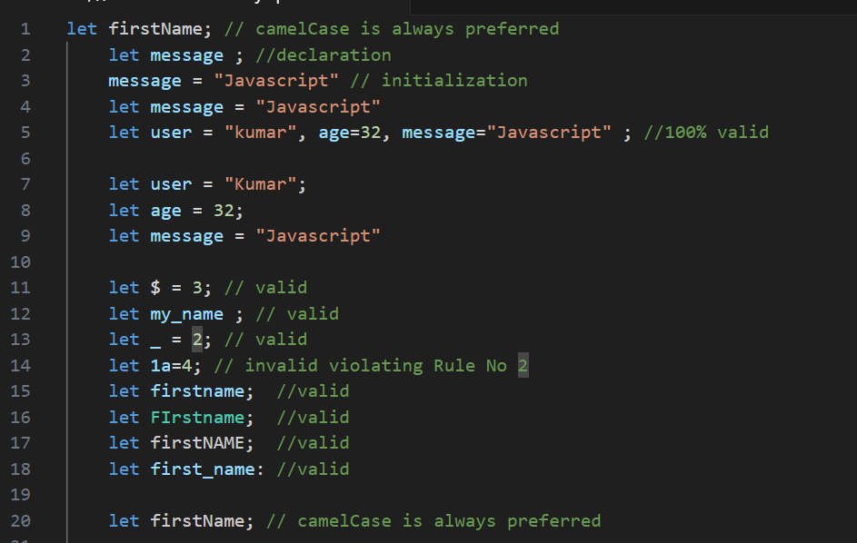

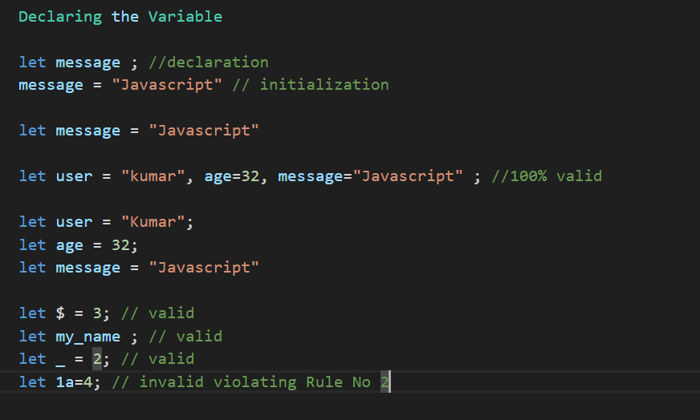

4. Variable Names are Case Sensitive
let apple;
let aPple;
// both are not same in javascript

5. Should not use keywords/reserved words
let let=10; // error
https://www.w3schools.com/js/js_reserved.asp

Hoisting
Hoisting means it is a mechanism where it moves the variable/function declaration to the top of its nearest scope but with let and const hoisting will not work .
Scope/Memory
var is a function level scope and will be available throughout the function
let/const are block level scope { } which will be access only in that block.
Redeclaration / Updation
var supports redeclaration and updation.
let supports only updation
const no redeclaration / updation will takes place.
For objects/arrays, the reference is constant — but the contents can be modified.
EXAMPLE:
VAR redeclare and update:
var a = 10;
var a = 15; ---- redeclaration allowed
var a = 98; --- redeclaration allowed again
a = 100; --- updation allowed
console.log(a); // 100-Now “a” holds value as 100.

var a; -- re-declaring again (safe with var)
console.log(a); --- a is declared but not yet assigned, JavaScript initializes it with undefined
a = 10;
console.log(a); --- 10 Now “a” holds value as 10.

LET — redeclare and update
let b = 15;
let b = 20; --- ❌ Error: Identifier 'b' has already been declared(You cannot declare let b again in the same block or scope.)
b = 100; --- ✅ Updating is allowed.
console.log(b); --- 100

CONST — redeclare and update:
const k = 10;
const k = 20; --- ❌ Error: Identifier 'k' has already been declared
k = 25;-- ❌ Error: Assignment to constant variable.

const with Arrays —reassigning array is not possible but we can change value for the index of arr
const arr = [1, 2, 3, 4];

arr = [5, 6, 7]; // ❌ Error: reassignment not allowed
arr[0] = 0; // ✅ Allowed — modifying an element
console.log(arr); // [0, 2, 3, 4]
var in a loop
- var is function-scoped, so it’s accessible anywhere inside the function, even outside the loop.
- If you try to access it outside the function, it throws an error.
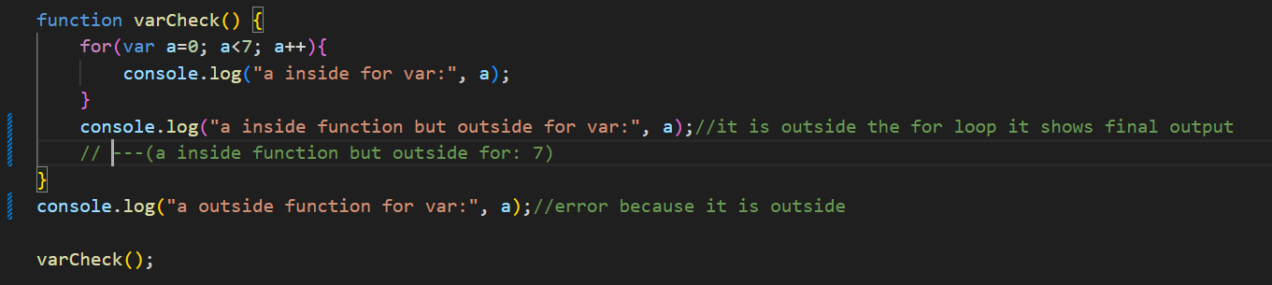
let in a loop
- let is block-scoped, so it exists only inside the for loop block.
- Trying to access it outside the loop or outside the function throws an error.
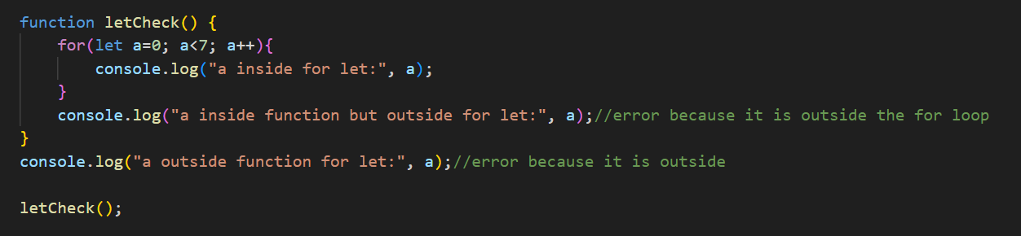
const in a loop
- Like let, const is block-scoped.
- However, you can’t reassign a const value, so typically in loops, you'd use let unless it's a fixed value.
- In your example, you’re using let — but for clarity, here’s how it works if it was const (which would throw an error on the second loop):
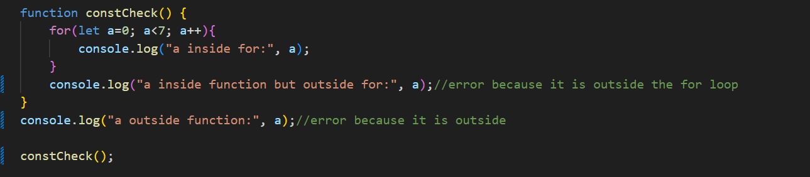
DataTypes?
Data type used to store single value are known as Primitive data types.
1.number
Numbers are pure numeric values like 101.
It mentions terms like phone, rating, pincode — these are examples of real-world data that usually store numbers.
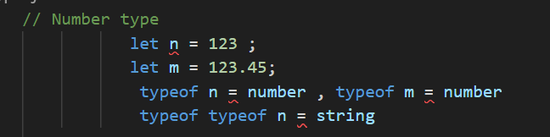

2.string
Any data enclosed within double quotes (" "), single quotes (' '), or backticks (\ `) is considered a string type.
Strings can consist of:
- Letters (e.g., "hello")
- Letters + numbers (e.g., "abc123")
- Letters + special characters (SC) (e.g., "abc@#!")
- Letters + numbers + special characters (e.g., "abc123@#!")
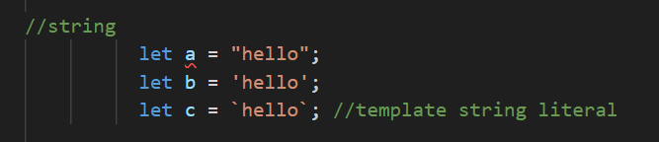
3.boolean
Any data which is mentioned in the form of true or false.
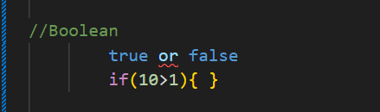
4.symbol
Any data which is created using symbol constructor.
5.undefined
- JavaScript provides a special value called undefined.
- If a variable is declared but not assigned any value, it automatically becomes undefined.
- The type of undefined is also undefined.
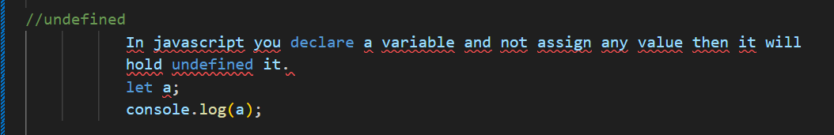
6.null
null is a special value in JavaScript, used to represent an intentional absence of any object value.
Reference to non-existing object.
typeof null returns "object".
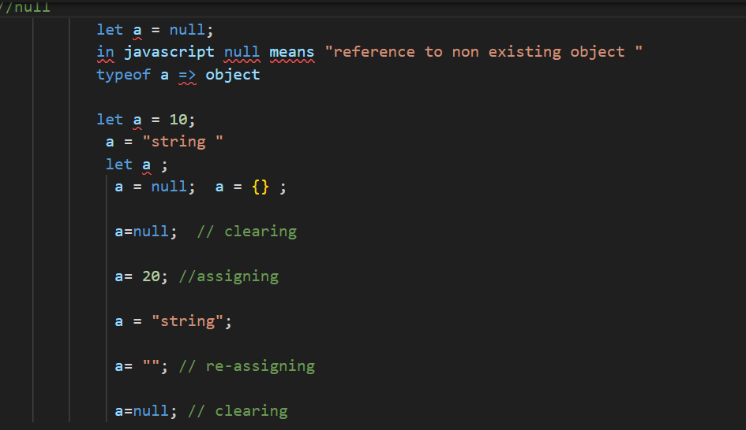
7.bigInt.
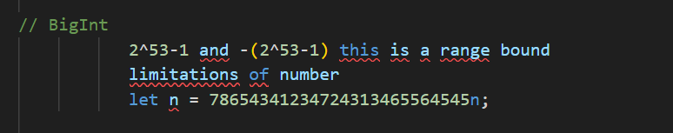
Non-Primitive: OBJECT, ARRAY
Data types are used to store multiple values are known as Non-Primitive Data types
object
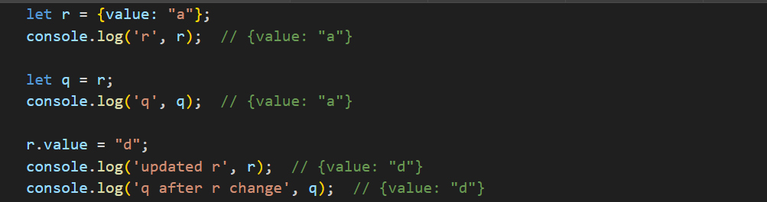
Now q and r are dependent because they both refer to the same object
Objects ?
Non primitive datatypes used to store multiple values or collection of various datatypes.
An object is a simple data structure used to store and manage data.
data will be stored in the object in Property Format 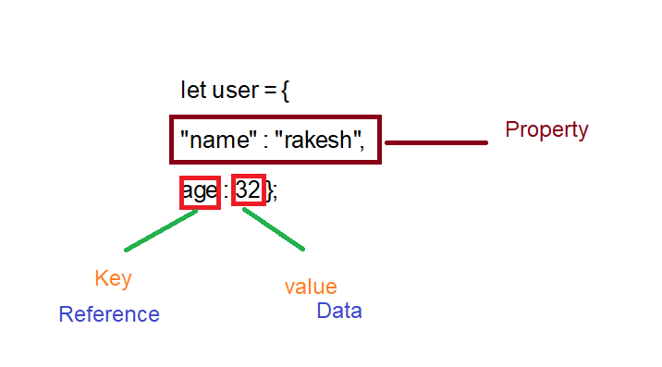
- Keys (also called properties) are unique strings.
- Values can be any data type — numbers, strings, arrays, functions, or even other objects.
ways to declare object?
let user = new object(); //object constructor syntax
let user = {} //literal notation
Example of LITERAL NOTATION
let user = {
"name" : "rakesh",
age : 32s };
To access the object properties, we have (.dot) notation and ([]square) notation.

Arrays ?
Non primitive datatypes used to store multiple values.
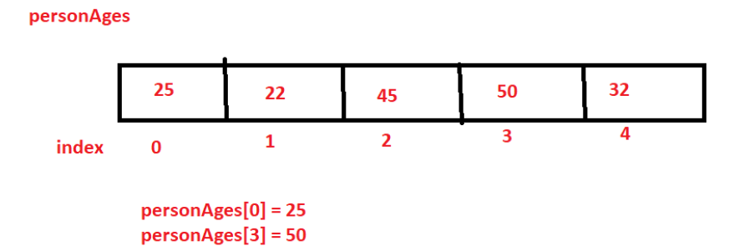
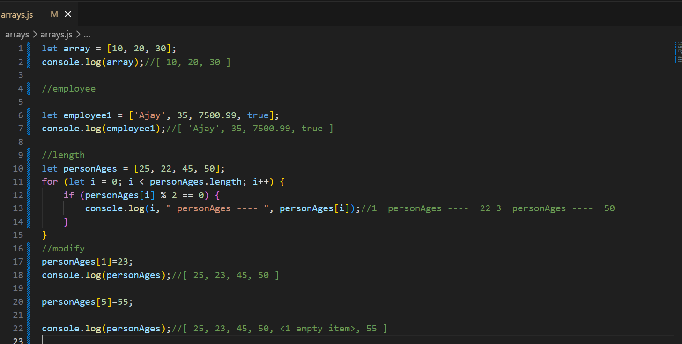
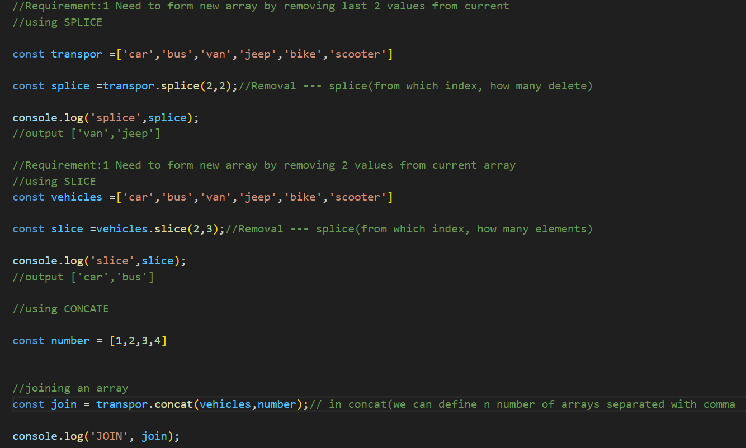
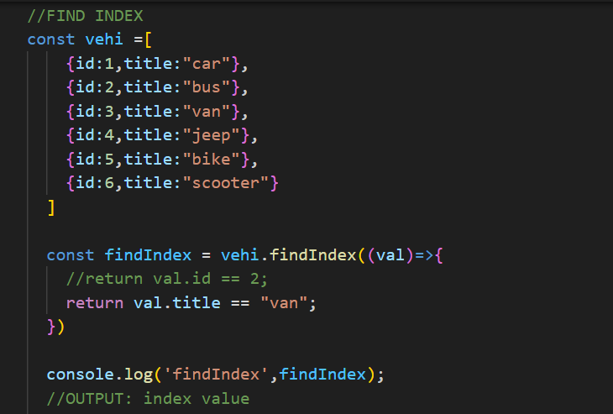
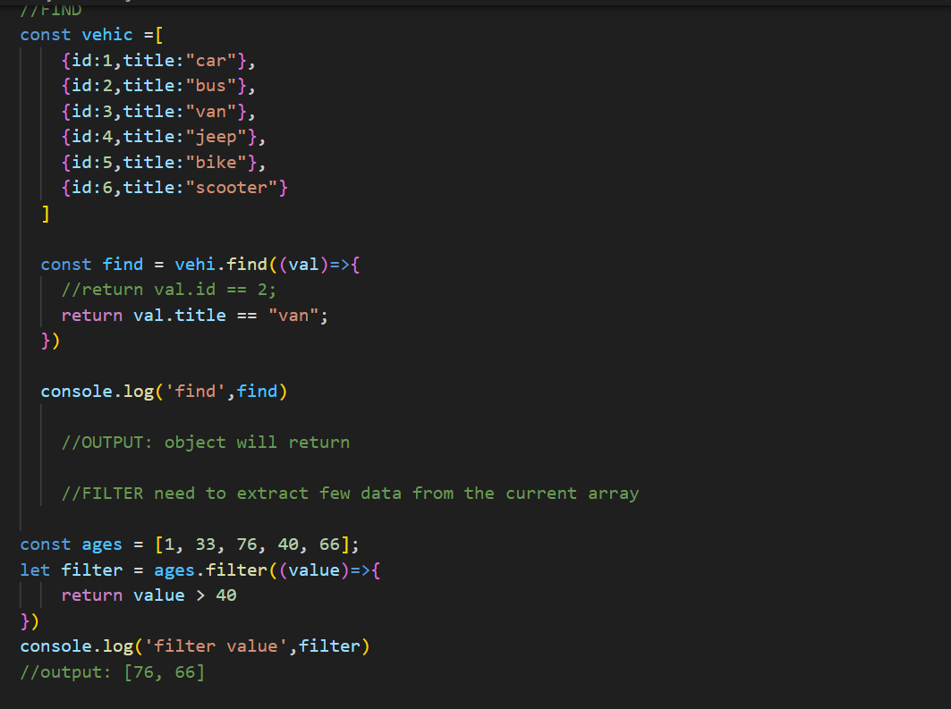
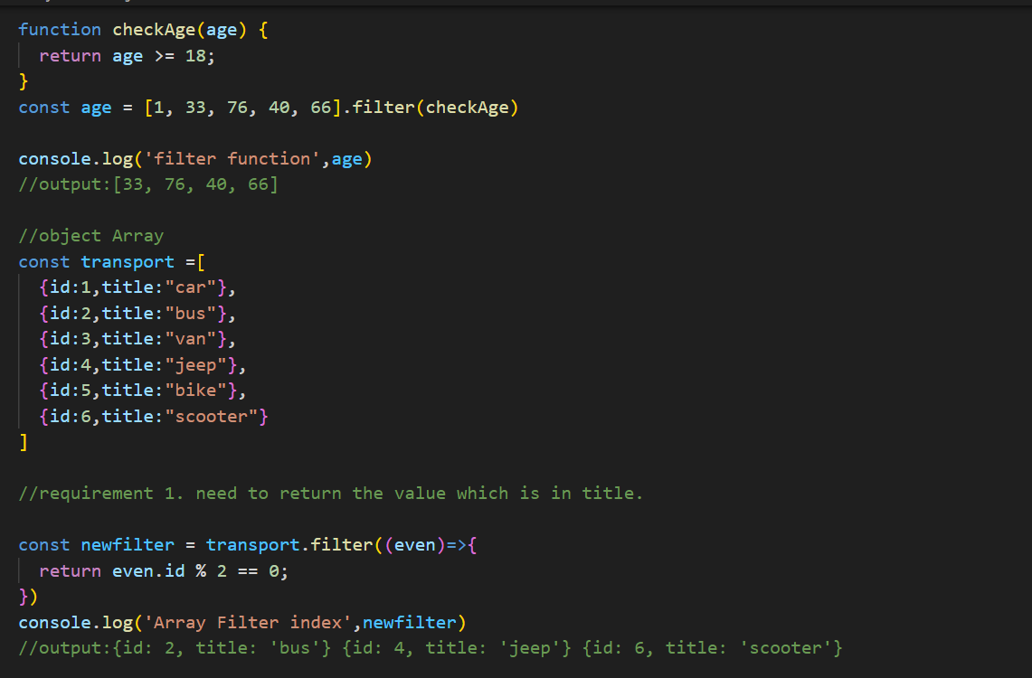
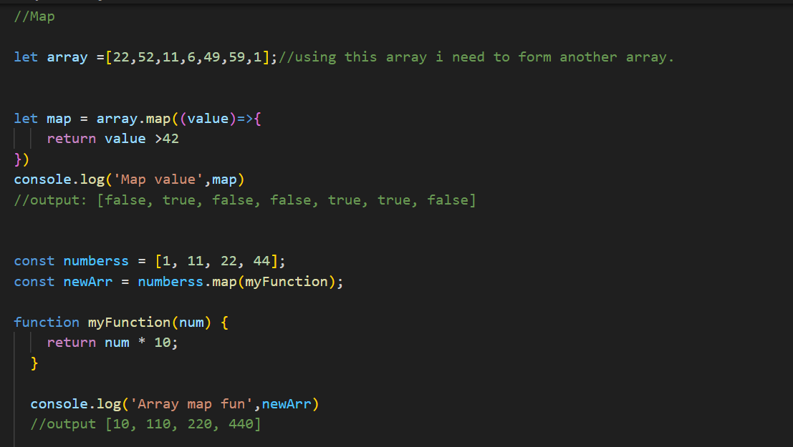
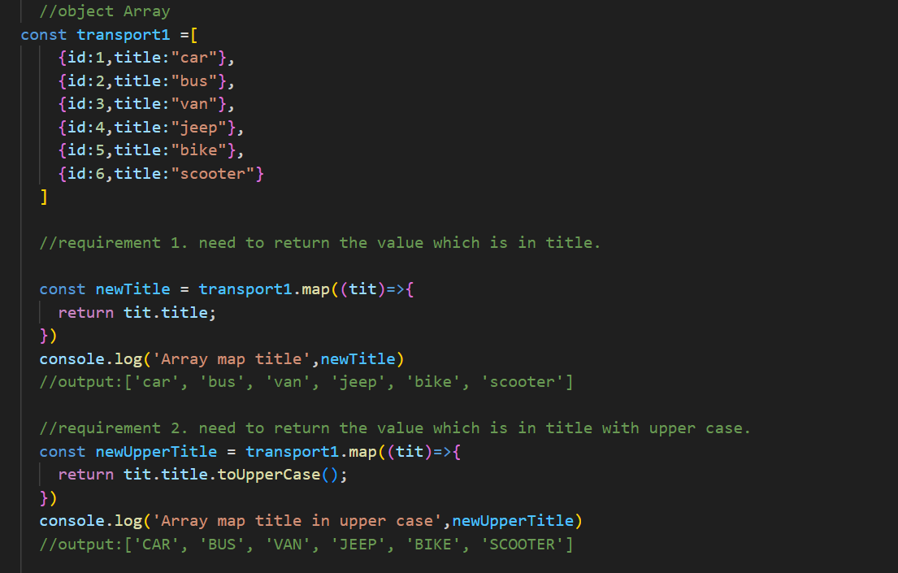
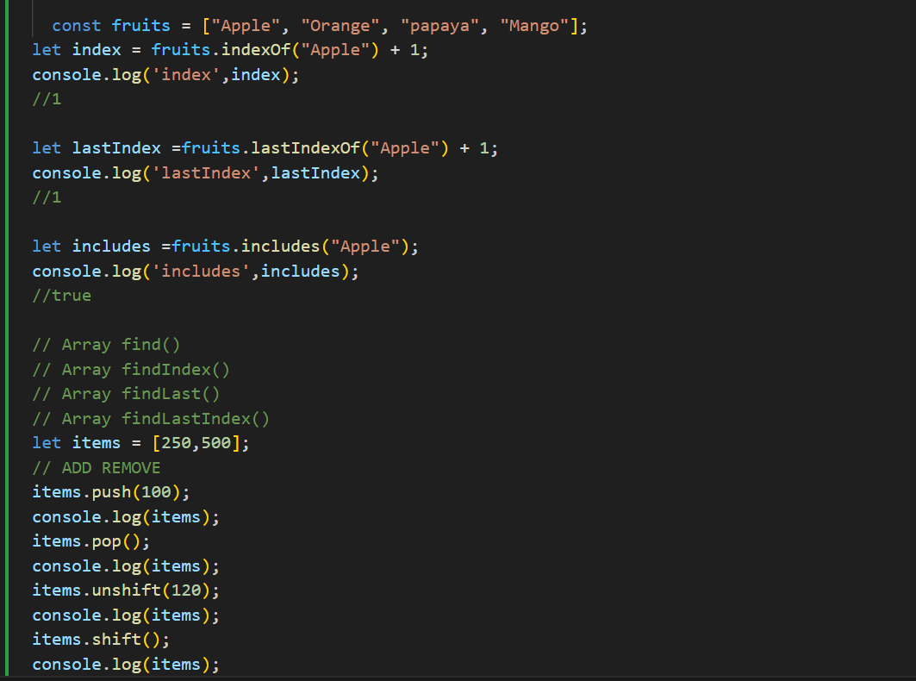

Function
Functions are building blocks, allow not to repeat the code. (Runs Only when you call it)
Parameters → Variables in the function definition.
Arguments → Values passed to the function when calling it.
Two types: Function Declaration and Function Expression
Function Declaration
supports hoisting.
a named function using the function keyword.
Function Expression
doesn’t support hoisting.
defines a function and assigns it to a variable

Conditional Statements?
execute different code blocks based on certain conditions (true/false).
If, if else, if elseif else:
drawback of multiple elseif condition is Poor Readability, Hard to Maintain, Performance (in some cases), Not Scalable.
Switch: Used to select one of many code blocks to be executed.
Ternary Operator: (condition ? expr1 : expr2) is a concise way to write an if-else statement in a single line.
condition ? trueBlock : falseBlock;
let num = 13;
let result = num % 2 == 0 ? "even" : "odd";
console.log(result); // Output: "odd"
When you need the index and more control (e.g., skipping, reversing)
Arrays (or anything indexable)
Initialize; condition; increment/decrement;
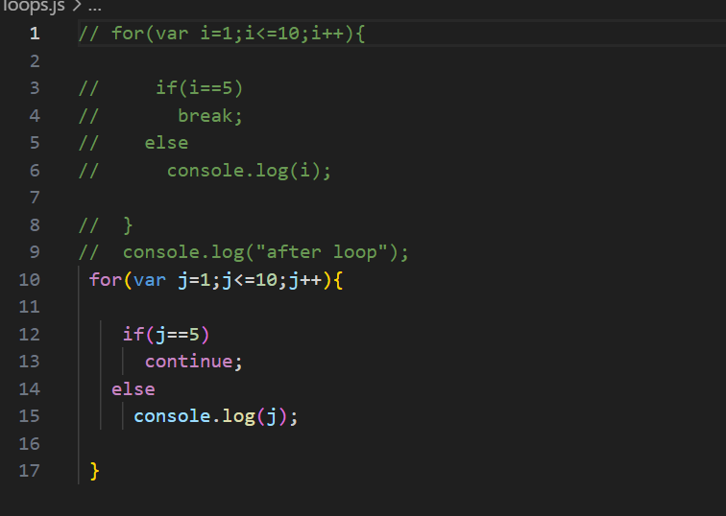
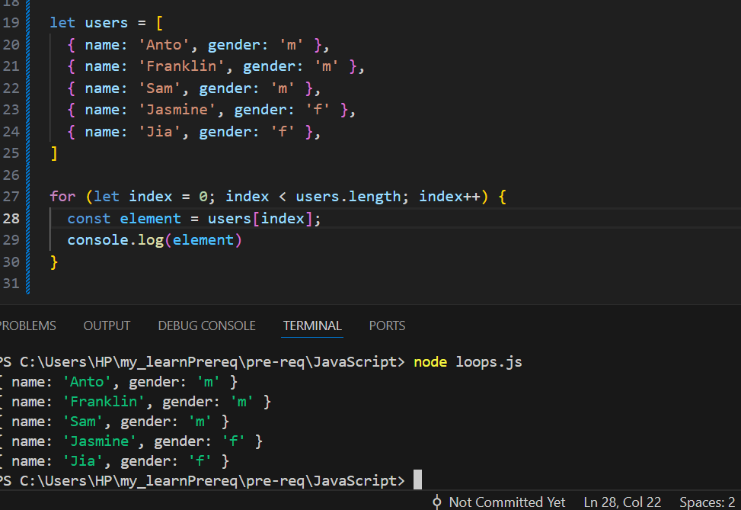

Loops?
Loops are way to repeat the same code number of times Until condition is false.
Iteration: Execute a definite number of times.
Initialization, condition, inc/dec
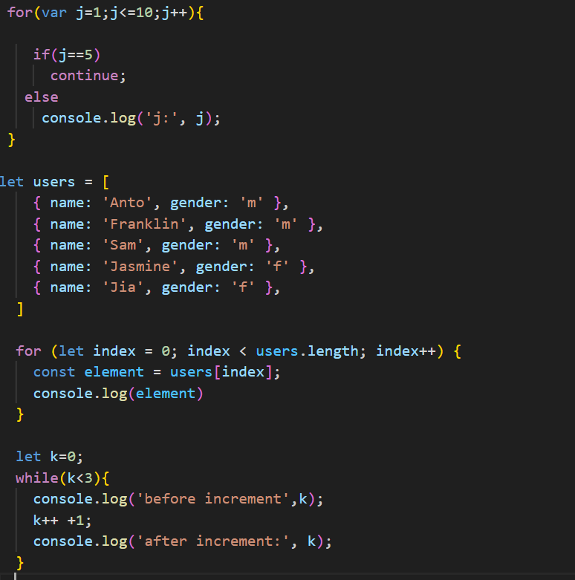
FOR IN & FOR OF
FOROF
Iterating values of iterable objects (arrays, strings, etc.).
Arrays, Strings, Sets, Maps, etc. (Not plain objects)

FORIN is used to iterate over the enumerable properties (keys) of an object—( technically be used on arrays)
Iterating keys (property names) of an object
Objects, Arrays (but returns keys/indexes as strings)

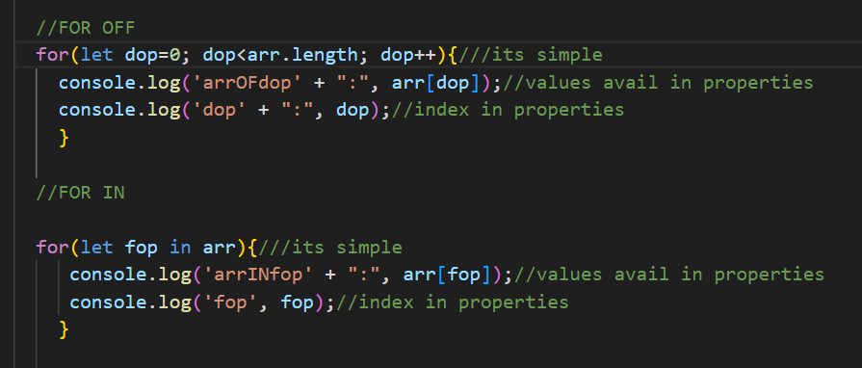
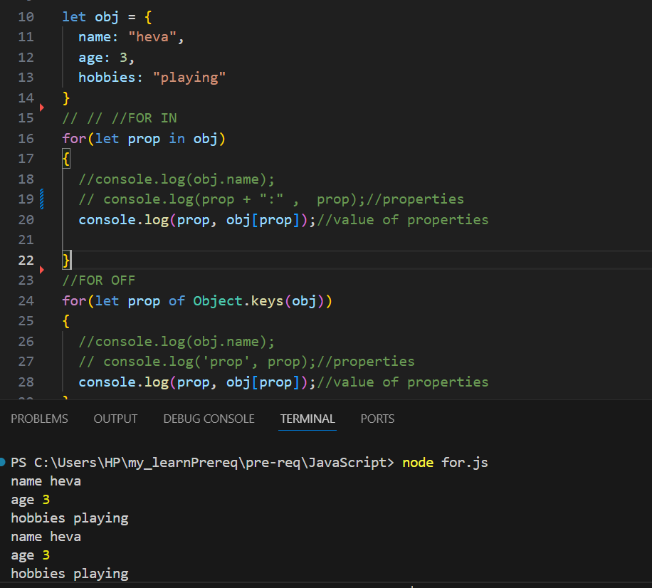
Hint: Falsy values in JavaScript: 0, NaN, undefined, false
To extract values from arrays or properties from objects and assign them to variables.
Points to Remember:
- Destructuring helps avoid repetitive dot notation (ObjectName.PropertyName).
- Variable name must match the key name when destructuring the object.
- You can assign default values to avoid undefined for missing properties.
- Default values apply only to keys not present in the object.
Note: While destructuring, we can provide default values, but those default values do not become part of the original object or array.
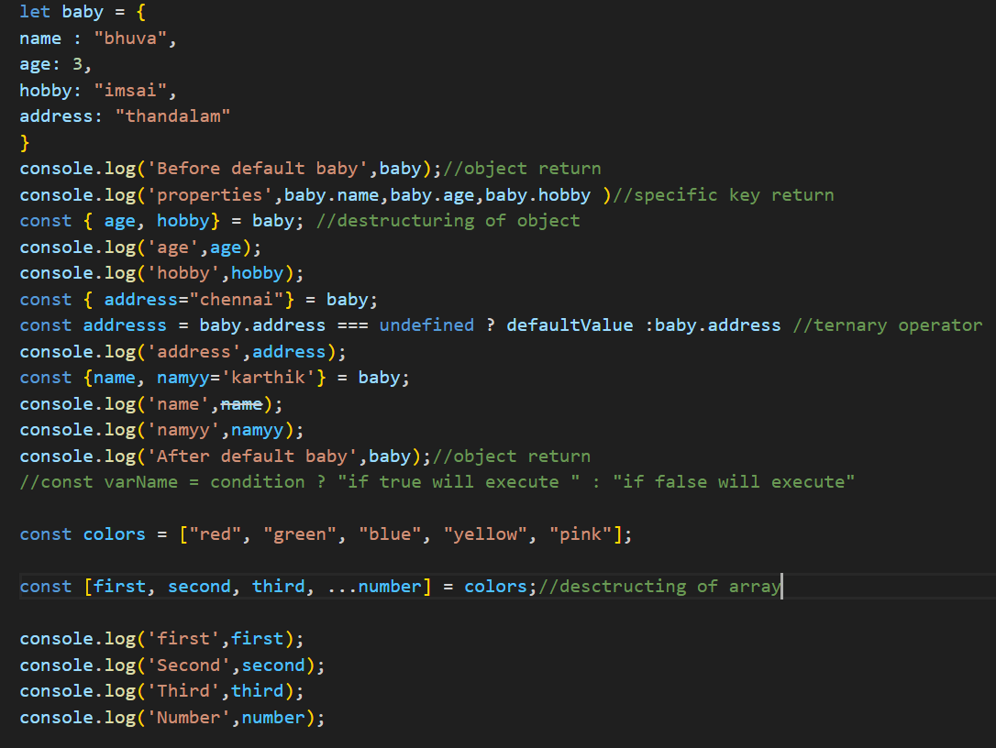
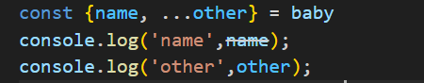
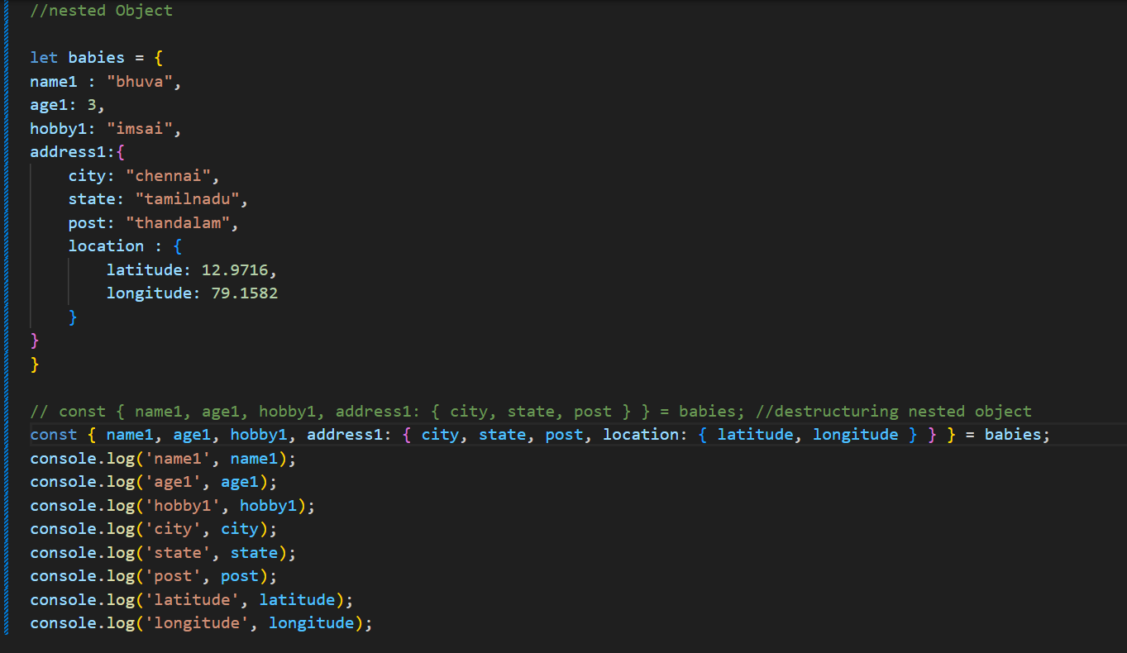

Optional Chaining?
Optional chaining (?.) helps write error-free code by safely accessing nested object properties.
It will return undefined instead of throwing an error.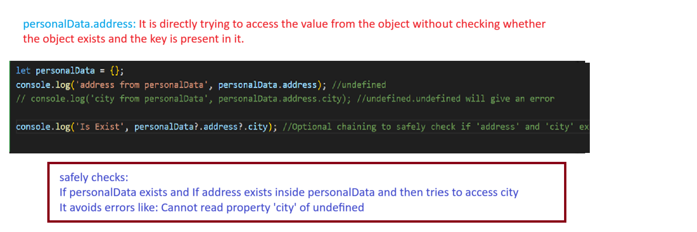

Arrow Function?
arrow function is a simplified code, or reduce of lines.
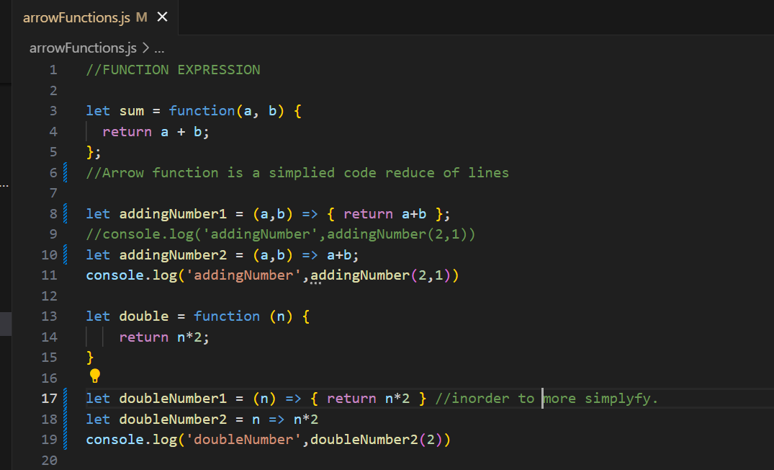

SCOPE:
Local Scope: { inside Curly braces } limited
Global Scope: It is accessible to all over the program
What is Event Loop in JavaScript?
JavaScript is single-threaded—it has only one call stack and executes one command at a time but it's designed to be non-blocking, which it achieves using the event loop in coordination with the Web APIs, callback queue, and microtask queue.
The Event Loop is a fundamental part of JavaScript’s runtime. It allows non-blocking, asynchronous operations (like setTimeout, Promises, and API calls) to execute without stopping the main thread.

Event Loop – How it Works:
Call Stack
- Executes all synchronous code line-by-line.
- Follows LIFO (Last In, First Out) order.
- When a function is called, it’s pushed onto the stack.
- When execution finishes, it’s popped off.
Web APIs
- Provided by the browser environment (not part of JavaScript itself).
- Handle asynchronous tasks like:
  - setTimeout, setInterval
    - Used for scheduling code execution after a specified delay.
setTimeout(() => console.log("Hi"), 1000)
  - fetch / XMLHttpRequest
    - Handles HTTP requests asynchronously to retrieve or send data from/to a server. Returns a Promise.
fetch('/api/data').then(res => res.json())
  - DOM API.
    - Allow JavaScript to interact with and manipulate the Document Object Model (HTML elements).
document.querySelector("button").addEventListener("click", ...)
  - localStorage, location, console
    - Provides a way to store key-value pairs persistently in the browser.
localStorage.setItem('theme', 'dark')
    - Provides info about the current URL and allows navigation to new URLs.
window.location.href = 'https://example.com'
    - For logging data to the browser console — used for debugging and inspection.
console.log("Debug Info")
- Once these tasks finish, their callbacks are sent to a queue (microtask or macrotask).
Callback Queue (Macrotask Queue)
- Stores callbacks from Web APIs after async operations complete.
- Examples:
  - setTimeout, setInterval, setImmediate
  - I/O operations
  - DOM event callbacks
- The Event Loop picks one macrotask at a time to execute (after microtasks finish).
Microtask Queue
- Holds high-priority asynchronous tasks that need to run immediately after the current stack is clear.
- Examples:
  - Promise.then(), Promise.catch(), queueMicrotask()
  - MutationObserver
- The Event Loop always executes all microtasks first before moving to macrotasks.
Event Loop
- Continuously monitors and coordinates between the Call Stack and the task queues.
- Its algorithm:
  - Check if the Call Stack is empty.
  - If yes:
    - Execute all microtasks from the Microtask Queue (in order).
    - Then execute one macrotask from the Callback Queue.
  - Repeat this cycle indefinitely.
Functions?
functions are the building blocks, reuse code(Allow not to repeat the code) and organize logic
Function Declaration and Function Expression.
Function Declaration follows Hoisting so calling is possible without declaration.
Function expression calling is not possible without declaring it.
function declaration
sum(5, 5); -- Can be called before declaration due to hoisting
function sum(a, b) {
return a + b;
}
console.log("sum:", sum(5, 5)); -- 10
Function Expression:
A function is assigned to a variable.
let add = function(a, b) {
return a + b;
};
console.log("Addition:", add(5, 10)); -- 15
Calling add() before this line would cause an error because hoisting is not supported.
console.log(add(5, 10)); -- Error: Cannot access 'add' before initialization.

Arrow Functions?
Arrow Function: (introduced in ES6)
quick and neat way to write functions example:
in FUNCTION EXPRESSION we have to write code to sum of 2 variables.
let sum = function(a, b) {
return a + b;
};
arrow function is a simplied code reduce of lines
Example with return:
let addingNumber = (a,b) => { return a+b };
console.log('addingNumber',addingNumber(2,1))
Even shorter
let addingNumber = (a,b) => a+b;
console.log('addingNumber',addingNumber(2,1))
ANOTHER EXAMPLE:
let double = function (n) {
return n*2;
}
//let doubleNumber = (n) => { return n*2 } inorder more simplyfy.
let doubleNumber = n => n*2
console.log('doubleNumber',doubleNumber(2))

ES6 Basics (like let, const, spread/rest operators, etc.)?
Let const already explained above.
//Requirement:1 Need to form new array by removing last 2 values from current
//using SPLICE

const transport =['car','bus','van','jeep','bike','scooter']

const splice =transport.splice(2,2);//Removal --- splice(from which index, how many delete)

console.log('splice',splice);
//output ['van','jeep']

//Requirement:1 Need to form new array by removing 2 values from current array
//using SLICE
const vehicles =['car','bus','van','jeep','bike','scooter']

const slice =vehicles.slice(2,3);//Removal --- splice(from which index, how many elements)

console.log('slice',slice);
//output ['car','bus']

//using CONCATE

const number = [1,2,3,4]

//joining an array
const join = transport.concat(vehicles,number);// in concat(we can define n number of arrays separated with comma

console.log('JOIN', join);

//FIND INDEX
const vehi =[
{id:1,title:"car"},
{id:2,title:"bus"},
{id:3,title:"van"},
{id:4,title:"jeep"},
{id:5,title:"bike"},
{id:6,title:"scooter"}
]

const findIndex = vehi.findIndex((val)=>{
//return val.id == 2;
return val.title == "van";
})

console.log('findIndex',findIndex);
//OUTPUT: index value

//FIND
const vehic =[
{id:1,title:"car"},
{id:2,title:"bus"},
{id:3,title:"van"},
{id:4,title:"jeep"},
{id:5,title:"bike"},
{id:6,title:"scooter"}
]

const find = vehi.find((val)=>{
//return val.id == 2;
return val.title == "van";
})

console.log('find',find)

//OUTPUT: object will return

Asynchronous
In JavaScript, execution happens line by line. If a particular block of code is heavy, it can block the rest of the code and make it wait until that block finishes. To avoid this blocking, we can move the heavy operation to asynchronous execution.

Call Backs?
Certainly! A callback function in JavaScript is a function that is passed into another function as an argument to be executed later.
Used to achieve asynchronous way of programming.
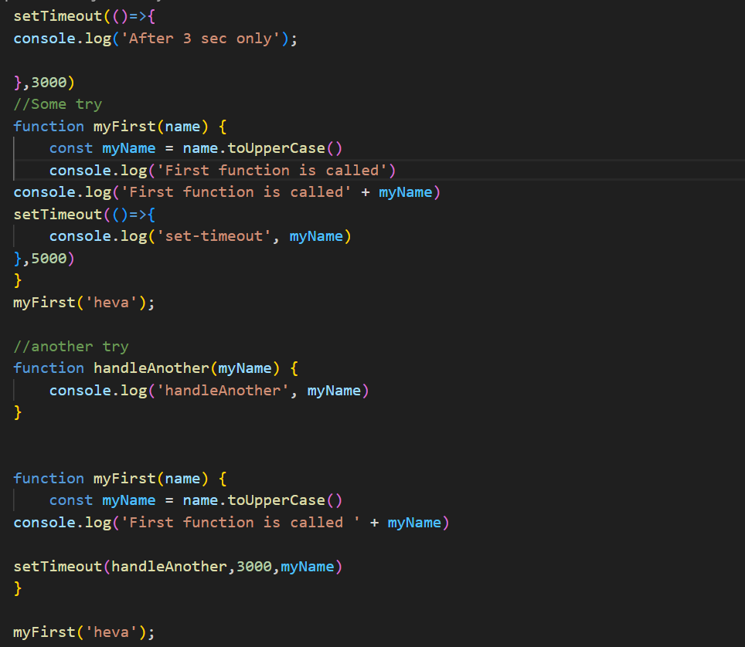

Import & Export?
- ES6 concepts
We can achieve reusable concepts using Import & Exports concept.
export is used to expose a module's functionality—like functions, variables, or classes—so they can be imported and used in another JavaScript file. Similarly, import is used to bring in exported items from other modules.
Why we have to use Promises ?
If there is any heavy operation in JavaScript—like fetching data, performing complex logic, or accessing files—that takes more time to complete, it can delay the normal execution flow since JavaScript runs in a single-threaded environment.
To avoid blocking the main thread, we handle such tasks asynchronously. However, if we want to maintain a controlled, step-by-step (synchronous-like) flow, we use Promises or async/await.
What is Promises ?
A Promise is a (special object or data structure) in JavaScript used to handle asynchronous operations.
Promises allow us to run heavy code separately without interrupting the main execution, and they also let us chain or wait for tasks in a readable and manageable way
A Promise represents a value that may be available now, in the future, or never.
A Promise has three possible states:
- Pending — The operation is still in progress.
- Fulfilled/resolved /Success— The operation completed successfully.
- Rejected /Failure/ Error— The operation failed.
How to Create a Promise Object ?
To create a Promise, we must use
- new Operator
- Promise() (pre-defined constructor)
const prom = new promise((resolve,reject)=>{})

EXAMPLE:
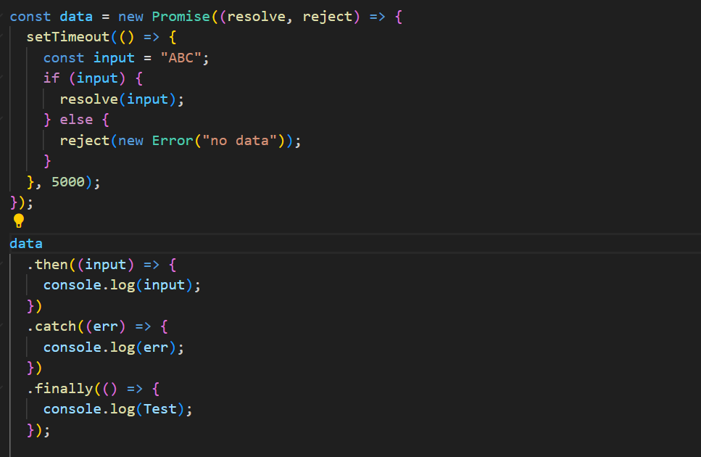
using API call
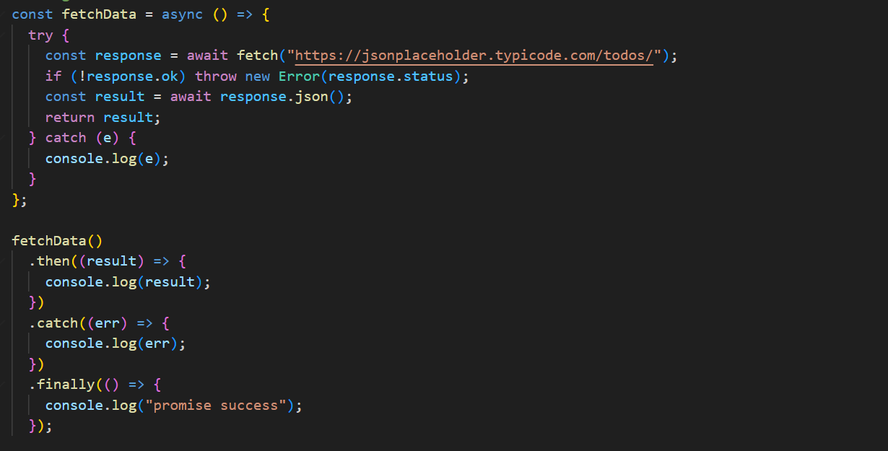

Use is Promise?
- It avoids callback hell by chaining asynchronous steps with .then() and handling errors in a single .catch().
- It provides a consistent pattern to manage async operations like API calls, timers, or file I/O.
- With async/await, Promises allow asynchronous code to be written in a synchronous style, improving readability.
Why promise differs from other asynchronous?
- Unlike traditional callbacks, Promises are composable (Promise.all, Promise.race, etc.), making complex async flows easier to manage.
- Promise callbacks (then/catch) run in the microtask queue, which has higher priority than macrotasks like setTimeout. This gives more control and predictability.
- Promises standardize async handling, while plain callbacks depend on the implementer’s design, often leading to messy code.
What is Object in Promise?
In JavaScript, an Object just stores data in key–value pairs. A Promise is also an object, but its purpose is different: it represents the result of an asynchronous task. A Promise can eventually give back any type of value—often an object. So, when we say object in Promise, it usually means the Promise resolves with an object as its result.
Basic DOM Manipulation (optional)

